ANIMAL NUTRITION & HEALTH PROGRAM

Allen L. Stout, D.V.M.
The following Animal Nutrition and Health Program was formulated over several years on the Ambassador College farm program in East Texas, and was presented at a joint seminar sponsored by Ambassador College and Texas A & M University East Texas Research Center in Overton, Texas for cattlemen. East Texas is an area of badly depleted soils, poor cattle and many disease and parasites problems (see Ambassador Agriculture and Animal Health Program).
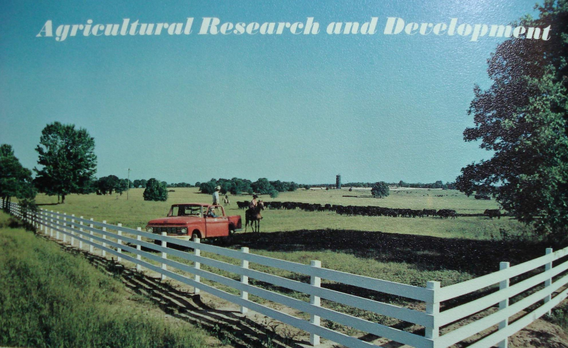
The Cattle nutrition and health program was developed to be a totally integrated program combining management of soils, crops and livestock. It is based on an analysis of the factors causing poor production and disease to help determine management practices that can be applied to prevent disease and promote optimum health and production. Soil, feed and animal testing and research was used to analyze and help solve production and health problems and improve management.

GENERAL PRINCIPLES
Major factors that were analyzed and found to cause poor production and disease include:
1. Poor hereditary quality of animals. An animal cannot produce more than its hereditary or genetic potential. In addition to poor production inherited genetic weaknesses and defects also often predispose (weaken) animals to poor health and disease problems.
2. Nutritional deficiencies, imbalances and excesses. These factors cause inefficient production and also predispose to or cause other diseases including digestive, nutritional and metabolic diseases such as ketosis, grass tetany, milk fever, etc. and weaken resistance to stresses, such as inclement weather conditions and to parasitic and infectious diseases.
3. Poisonous plants and toxic substances. These usually result from poor pasture management and improper use of fertilizers, pesticides, drugs and other chemicals.
4. Stresses and injuries. These commonly result from improper handling and shipping, inadequate facilities, exposure to adverse or severe weather conditions, fighting, etc.
5. Infectious and parasitic agents. These include a host of pathogenic bacteria and viruses, internal parasites, such as roundworms, flukes, tapeworms, stomach worms, etc., and external parasites, such as ticks, lice, horn flies, mites, etc.
Good overall management is the key to efficient production and disease prevention. Management factors important for control and prevention include:
1. Following sound selection and breeding practices, including selection and breeding strong, healthy, resistant animals and culling weak, poor producers. Also, plan the breeding program to make best use of the forage program.
2. Providing a good clean supply of water. Inadequate or polluted or high mineral waters can cause serious nutrition and health problems and reduce production. Testing the water may help determine the cause of some problems.
3. Providing sufficient variety and amounts of good quality feeds in proper balance. Supplements may be necessary to make up for deficiencies in quality and variety of feeds.
4. Following good pasture management practices, proper use of fertilizers, and pesticides, rotations, etc. Well-nourished animals are less likely to eat poisonous plants and toxic substances. Some herbicides can cause plants to accumulate toxic levels of nitrates.
5. Avoid over-stressing animals in handling and shipping and provide proper facilities including shelter or protection from sever weather conditions, such as excessive heat, wet, cold winds, etc.
6. Maintain good sanitary conditions, avoid over-crowding in pens and lots. Avoid overgrazing and rotate pastures where possible to prevent buildup of internal parasite problems. Provide clean feed and water supplies; use hay racks and water tanks where possible; put young, growing calves on the best and cleanest pastures; maintain high levels of immunities and resistance through good nutrition and other factors; test, isolate or quarantine and treat sick animals properly when necessary.

A PRACTICAL NUTRITION PROGRAM
Poor animal nutrition is one of the major causes of low production and poor resistance to diseases and parasites. The following program was developed to correct nutritional and toxic conditions that were major problems in the beginning on the college farm.

I. Nutrition begins in the soil.
Fertile soil and good weather are required to produce good yields of the high quality feeds necessary as the basis of a good low cost nutrition program.
East Texas generally has favorable weather conditions for good production much of the year. But East Texas soils for the most part, tend to be mineral-poor. Much of the limited fertility had already been farmed out under cotton years ago.
In trying to formulate a complete and balanced nutritional program, it became evident that nutrition needed to be tied together with the soil fertility program, as most of the deficiency and toxic problems seen in animals were traced to soil deficiencies and improper use of fertilizers.
Imbalanced fertilization resulted in nutritional deficiencies and toxicities in the cattle. Copper deficiency and molybdenum toxicity caused scours in cattle as a result of over-liming of soils that have very little capacity for lime. Nitrate toxicity, causing vitamin A deficiencies resulting in weak calves and severe pink-eye problems, occurred from using only small amounts of nitrates on soils devoid of organic matter and deficient in sulfur and other nutrients. Magnesium deficiencies were found to be related to problems of grass tetany, retained afterbirth, calf scours and brucellosis susceptibility. Hornfly problems diminished greatly when sulfur was supplemented along with other minerals.

Soil Testing
As a result of these and other problems and observations, I initiated an extensive soil and feed testing program utilizing the services of United States Testing Company, Inc. in Memphis, TN, and later of Brookside Farms Laboratories Association in New Knoxville, Ohio, to assist in analyzing the soil fertility, feed quality and management needs (see "Keys to Understanding Soil's & Soil Testing for Sustainable Soil Management" ). We also utilized the services of the Soil Conservation Service to help develop proper land use and management programs. Soils were analyzed for:
- Total Exchange Capacity (capacity for holding mineral fertilizer nutrients);
- pH (test of soil acidity or alkalinity);
- Percent of Organic Matter (humus);
- Soil Anion Minerals (Nitrogen, Phosphates, Sulfates);
- Soil Cation Minerals (Calcium, Magnesium, Potassium, Sodium and Hydrogen, and their relative balance);
- And Trace Minerals (Boron, Iron, Manganese, Copper, and Zinc) when the major elements are in proper balance.
When fertilizer materials are applied to build soil fertility and balance and promote an active living soil, the soil then provides nutrients in balance for optimum production and quality of crops at minimum cost.
Major deficiencies occurring in college farm soils included very low Organic Matter or humus (OM - which stores 95% of the soil's nitrogen), and very low Phosphorus, Sulfur, Calcium, Magnesium (in some soils), and Potassium.
These deficiencies were corrected by applications of rock phosphate, limestone (high-calcium and dolomitic types), K-Mag (potassium-magnesium-sulfate), muriate of potash (potassium chloride), potassium sulfate, gypsum (calcium sulfate), and animal manures, and cover crops. We also grew soil bacterial cultures in a concrete tank and applied to fields.
Legumes were utilized extensively, which provided a free source of nitrogen through nitrogen fixing bacteria in root nodules.
Many trace element deficiencies were also found including boron, manganese, copper and zinc. Some trace minerals were applied such as boron. Rock phosphare, lime and manures also supplied trace minerals. Livestock rations were also supplemented where deficiencies occurred. Norwegian kelp, a rich source of trace minerals, was included in livestock supplements and was also used in garden soils and proved to be very effective in increasing both animal and plant resistance to parasites and disease.
The value of proper pasture fertilization for increasing feed production and quality needs to be emphasized, especially in areas of mineral poor and highly leached soils such as East Texas. Fertilizers applied to pastures pay off more than once since they are recycled several times from the pasture through cows and back again to the soil in the manure. About 75% of the nitrogen, 80% of the phosphorus, and 85% of the potassium in the feed the cow eats passes out in the manure back to the land.
Special studies were run on a dairy pasture using cages to prevent grazing to compare the effects of fertilizer applications to non-fertilized control areas in the pasture.
$15.08 worth of fertilizer per acre (at 1972 prices) including 1000 pounds of rock phosphate for $11.00 and 100 pounds of potassium sulfate for $4.08 increased total production about 500 percent from 715 pounds of dry matter per acre to 4270 pounds of dry matter per acre. This amount of rock phosphate would need to be applied only about once in 5 to 10 years depending on the reserves of soil phosphorus and amount of crops removed without recycling.
The effects of proper fertilization on plant quality was also very encouraging. Carotene (pre-vitamin A) level in the feed increased about 135% from 42,500 USP units per pound to 99,780 USP units per pound. Phosphorus level increased 111%, potassium 71%, magnesium 50%, sulfur 46%, and others to lesser amounts. Iron showed a 40% decrease, which had been excessive before. The actual cost for the increased production was $8.48 per ton of dry matter. This does not count the carry-over value of the fertilizer to later production.
The net result of fertilization has been an increased carrying capacity of the land and greatly improved health and production of the college herds. Pastures that previously could not support the college herds provided a surplus of forage in 1972-73 and in 1974 allowed hay to be cut off the pastures for the first time while cattle grazed. Proper fertilization was a key part of this increase, however, weather was also an important factor in the increase. From the time the college kept a biblical land Sabbath or rest (see Leviticus 25:1-7 & 26:2-5) in 1972 and 1973 increases have been phenomenal. Without rains in due season, fertilizers would be of little value.

II. Selection and Management of Suitable Plant Varieties
Pasture and forage crops provide the best basis for a sound feeding program for cattle to provide Year-Round Nutritional Needs at Lowest Cost. The digestive system of cattle is best suited to utilizing forages making them efficient harvesters of land not as well suited to other crops or mechanical harvesting. In addition, the East Texas area is well adapted to year-round grazing. Properly managed pastures also build soil fertility in a 7 year rotation program with other crops (Leviticus 25:1-7).

Seasonal Plant Varieties
Summer grasses, legumes and forages utilized by the college include several varieties of the bermuda grasses, pensicola bahia, lovegrass, lespedeza, several varieties of clovers, sorghums, and cow peas. In addition to grazing and feeding green chop, hay and silage was put up from pasture areas, hay fields, and cultivated fields to supplement winter pastures.
Fall, winter and spring varieties include: Perennial grasses - fescue and rescue; interseeded annuals - rye grasses, yucci and crimson clovers, vetch; planting of small grains - oats, rye and wheat for grazing. Late spring grass and legume crops were also put up for hay and seed crops have been harvested.
Year-round grazing provides many advantages in nutritional quality for fast-growing calves, feeders, nursing and breeding cows and dairy cattle.

Nutritional Quality
The quality of feeds is related to their palatability, digestibility, nutrient contend, and the absence of toxic substances.
Quality is affected by soil fertility, weather conditions, plant genetic make-up and stage of growth. The objective of management is to maintain the highest quality that is economically feasible. Weather conditions such as drought may cause rapid changes in the quality. Excessive stemmy growth and maturity adversely affect quality. Proper grazing or clipping pastures stimulates new growth to maintain higher quality. Qvergrazing weakens the plant and reduces production.

Feed Testing
The cow is the final judge of quality, but feed testing provides a helpful measure of nutrient content and quality. Feed testing was included as part of the nutrition program to aid in balancing rations. Feeds were analyzed for:
- Percent Moisture,
- Crude Protein (Nitrogen - N x 6.25 = CP), (N/S ratio was used to determine true protein vs. toxic non-protein N),
- Digestable Protein (DP),
- TDN (Total Digestable Nutrients), and/or Net Energy (NE),
- Minerals - Calcium (Ca), Phosphorus (P), Potassium (K), Magnesium (Mg), Sodium (Na), Sulfur (S), Iron (Fe), Manganese (Mn), Copper (Cu), Zinc (Zn);
- and Carotene (Vitamin A);
- Nitrates or other factors may be tested when a problem is suspected;
- Water quality is also important and should be considered and tested when problems exist.

III. Formulating and Balancing Cattle Rations
The simplest way to formulate and balance cattle rations is to put them out on good quality pasture with a wide variety of plant types and let them select and balance their own needs. However, this seldom works in East Texas due to the many deficiencies in the soils and feeds. Nutritional deficiencies constitute one of the major causes of poor production and efficiency in this area. Without adequate feed nutrients, even well-bred cattle cannot produce efficiently.
The major nutrient requirements for cattle include water, energy (TDN or NE), digestable protein (DP), minerals (calcium, phosphorus, magnesium potassium, sodium, and trace elements) and vitamins (especially vitamins A, D and E). The specific nutritional requirements for individual animals differ due to differences in genetic make-up, age, capacity, growth rate and desired gain or production, pregnancy, lactation, work, stresses, sickness, etc. Fast-growing and high-producing animals will have the highest requirements.
Rations were balanced at the college by first determining the nutrient requirements for each group of animals using tables from Morrison’s Feeds and Feeding, National Research Council Publications and other books. Next a determination was made of the total feeds fed (and actually consumed). These are analyzed using either feed table values for dry matter (DM), total digestible nutrients (TDN), crude protein (CP), minerals and carotene or by an actual feed analysis. The difference between nutrients in feeds fed and the actual requirements of the cattle must be made up by extra feed or supplements.
The best quality feeds and pastures are reserved for the fast-growing and high-producing animals.
An important key to maintaining good nutrition and health is an alert, experienced herdsman or feeder who will closely observe how the cattle are doing.
When feed quality changes the feeder must be alert to recognize the change early before production and health are affected. Changing of rations should be gradual to allow the animals digestive system to adapt to the change, otherwise some animals may go off feed, bloat or founder.
In the final analysis, good animal health and efficient production is the result of a total program following sound, long-range management principles that anyone can apply. Beef and dairy production can be highly profitable, but success will depend upon good management practices.

©1974 Allen L. Stout; 2007 Serf Publishing, Inc.

